**CHAPTER III  
PROBLEM ANALYSIS**

### III.1 Types And Uses For Of Linear Barcode

|  |  |  |
| --- | --- | --- |
| **SYMBOLOGY** | **MAPPED** | **USES** |
| Code bar | Discrete | Old Format Used In Libraries And Blood Banks. |
| Code 25 – Non-interleaved 2 of 5 | Continuous | Industrial |
| Code 25 – Interleaved 2 of 5 | Continuous | Wholesale, libraries International standard ISO/IEC 16390 |
| Code 11 | Discrete | Telephones (out of date) |
| Code 39 | Discrete | Various – international standard ISO/IEC 16388 |
| Code 49 | Continuous | Various |
| Code 93 | Continuous | Various |
| Code 128 | Continuous | Various – International Standard ISO/IEC 15417 |
| CPC Binary | Discrete |  |
| DX film edge barcode | Neither | Color print film |
| EAN 2 | Continuous | add on code (magazines), GS1-approved – not an own symbology – to be used only with an EAN/UPC according to ISO/IEC 15420 |
| EAN 5 | Continuous | Add on code (books), GS1-approved – not an own symbology – to be used only with an EAN/UPC according to ISO/IEC 15420 |
| EAN-8, EAN-13 | Continuous | Worldwide retail, GS1-approved – International Standard ISO/IEC 15420 |
| Facing Identification Mark | Discrete | USPS business reply mail |

|  |  |  |
| --- | --- | --- |
| GS1-128 (formerly named UCC/EAN-128), incorrectly referenced as EAN 128 and UCC 128 | Continuous | Various, GS1-approved -is just an application of the Code 128 (ISO/IEC 15417) using the ANS MH10.8.2 AI Data structures. Its not an own symbology. |
| GS1 DataBar, formerly Reduced Space Symbology (RSS) | Continuous | Various, GS1-approved |
| Intelligent Mail barcode | Discrete | United States Postal Service, replaces both POSTNET and PLANET symbols (formerly named One Code) |
| ITF-14 | Continuous | Non-retail packaging levels, GS1-approved – is just an Interleaved 2/5 Code (ISO/IEC 16390) with a few additional specifications, according to the GS1 General Specifications |
| JAN | Continuous | Used in Japan, similar and compatible with EAN-13 (ISO/IEC 15420) |
| KarTrak ACI | Discrete | Used in North America on railroad rolling equipment |
| MSI | Continuous | Used for warehouse shelves and inventory |
| Pharmacode | Discrete | Pharmaceutical packaging (no international standard available) |
| PLANET | Continuous | United States Postal Service (no international standard available) |
| Plessey | Continuous | Catalogs, store shelves, inventory (no international standard available) |
| PostBar | Discrete | Canadian Post office |
| POSTNET | Discrete | United States Postal Service (no international standard available) |
| RM4SCC / KIX | Discrete | Royal Mail / Royal TPG Post |
| Telepen | Continuous | Libraries (UK) |
| Universal Product Code (U.P.C.) | Continuous | Worldwide retail, GS1-approved – International Standard ISO/IEC 15420 |

**Table 3.1 Types And Uses For Of Linear Barcode**

### III.2 Barcode Scanner as Reader of Linear Barcode

Barcode Reader also called a price scanner or Point of Sale (POS) is an electronic device that’s can capture and read the information contained in barcode to the device. Barcode reader merely captures and translates the barcode into number and/or letters, the data must be sent to a computer so the software application can make sense of the data. Barcode readers unlike magnetic stripe readers are non-contact automatic data capture devices, operate only at short distance (a few inches) and unlike in radio frequency identification don’t provide out of line of sight reading. The Type scanner reader of barcode:

1. Pen-Type Reader. The simplest barcode reader that consist of light source and a photodiode on the tip of the pen. Contain no moving parts for durability and low cost.

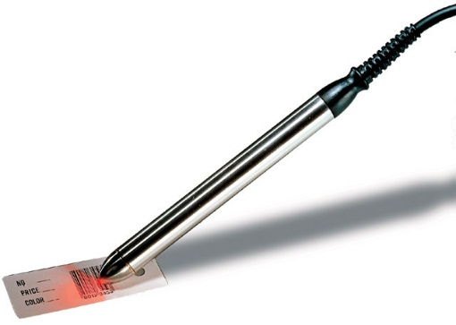

**Figure 3.1 Pen Type Reader** **(REF:** [**www.barcodesinc.com**](www.barcodesinc.com)**)**

1. Laser Scanner. Hand-held or stationary scanner, similarly to Pen-Type Reader but Laser Scanner uses a laser beam that have lenses to allow scanner to read the barcode regardless of orientation and can scan barcode up to 24 inches away.

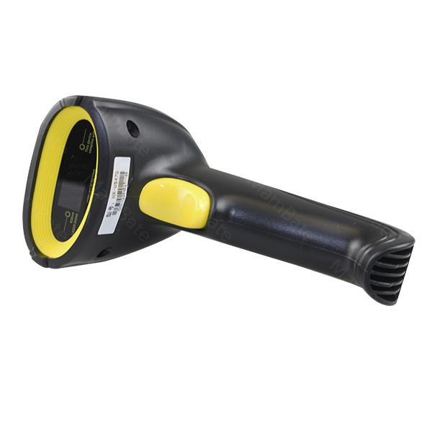

**Figure 3.2 Laser Scanner** **(REF:** [**www.aliexpress.com**](www.aliexpress.com)**)**

1. Camera-Based Reader or Image Scanner. Installed with camera and image processing techniques in reading barcode. Uses a small video camera to capture an image of barcode and then uses sophisticated digital image processing techniques to decode the barcode into character.

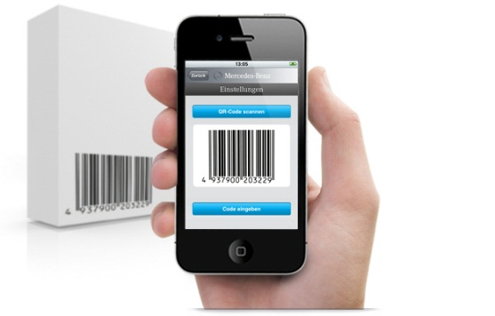

**Figure 3.3 Camera Based Reader (REF:** [**www.smartmobilefactory.com**](www.smartmobilefactory.com)**)**

1. CCD (Charge-Coupled Device) Reader. Improvements Pen Wand, have better read-range and often used in retail sales that typically similarly gun type interface. Scan the barcode with range one inch from the barcode with several light sensor to scanning the barcode.

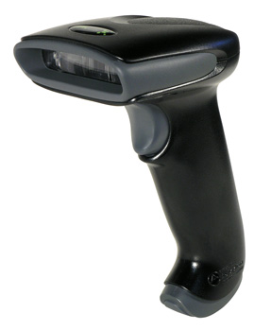

**Figure 3.4 CCD Reader** **(REF:** [**www.barodediscounters.com**](http://www.barodediscounters.com)**)**

1. Omni-Directional Barcode Scanner. The barcode reader that very efficient in decoding in badly printed, crumpled and even torn barcodes on product and highly advanced.

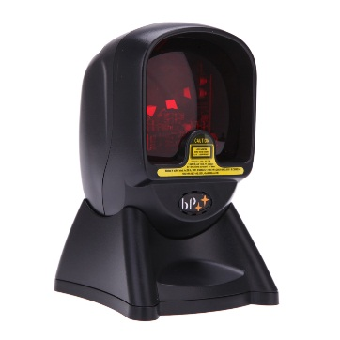

**Figure 3.5 Omni Directional Reader** **(REF:** [**www.aliexpress.com**](http://www.aliexpress.com)**)**

1. Slot Barcode Scanner. Stationary scanner typically used to scan barcode on identification cards, the item with the barcode its pulled by hand through the slot.

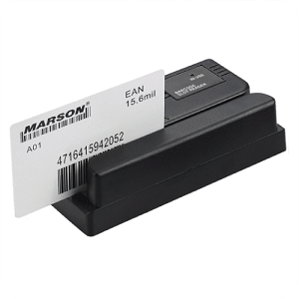

**Figure 3.6 Slot Reader** **(REF:** [**www.acesuppliers.com**](http://www.acesuppliers.com)**)**

### III.3 The Architecture Linear Barcode

Linear barcode have a structure like a quite zone before the start character and after stop character, start character and stop character, Intercharacter gap (only used in discrete codes) and Data Character. Linear barcode is built with single row of parallel bars and spaces of varying widths that represent data. Linear barcode only have 20-25 character in the code. The data in linear barcode only read horizontally.

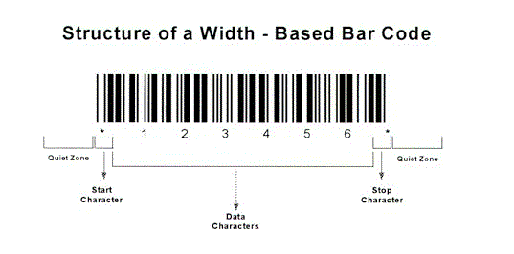

**Figure 3.7 Architecture Based Linear Barcode (REF:** [**www.detaid.com/whatisbarcode.htm**](www.detaid.com/whatisbarcode.htm)**)**

Scan rates scanner barcode of 100 scans per second is commonly and will be offer up to 800 scans per second. If the color of barcode absolutely solid, its can more be easily to be scanned with scanner. Not only the solid color, the distance of the scanner to scan the barcode important too. Long-range Linear Imagers can read out to 2 inch (40mm or 50mm), while its extended, that can lead up to 18 inch (460mm). Close Range scanning its uses for small barcode, and Long Range scanning its use for the large barcode.

Important to know where the scan line is as the reading distance is increases. Laser scanners, its clearly marked by the laser line but linear imagers depend on the illumination of the LEDs, as the result it will became more difficult to seeing as the reading distance increase or in high ambient light conditions such as the direct of sunlight.

Basic linear structure for the barcode words, representing each digit by unique pattern of bars and spaces with varying width that will be one, two, three or four modules wide. Total of width for digit is 7 modules. Example, to represent 12 digits of the UPC-A code, that must requires a total of 7 modules of total width then multiply with 12 digits of the UPC-A code, so the total modules of UPC-A code is 84 modules but the complete UPC-A is 95 modules, 84 module for the digit Left Pattern and Right Pattern that combined with 11 modules for the Start Pattern, Middle Pattern and End Pattern.

[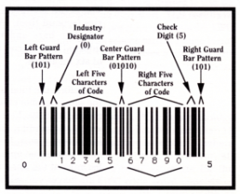](http://www.scholarpedia.org/article/File:Fig_2_Swartz_bar_code.png)

**Figure 3.8 Basic Architecture Linear Barcode** **(REF:** [**http://www.scholarpedia.org/article/Bar_code_scanning**](http://www.scholarpedia.org/article/Bar_code_scanning)**)**

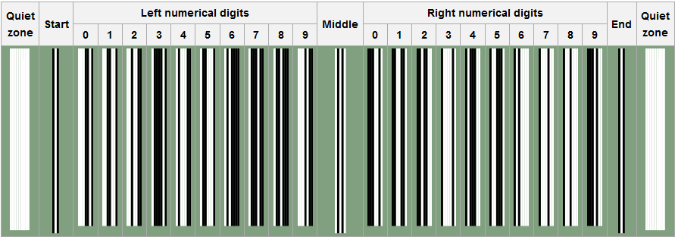Start Pattern and End Pattern are 3 modules wide and use the pattern Bar-Space-Bar (1-0-1) which each bar and space is one module wide. Middle pattern is 5 module wide and uses the pattern space-bar-space-bar-space (0-1-0-1-0) which each bar and space is one module wide. In UPC Code, Quite Zone (Additional space module) is requires before Start Pattern and after End Pattern.

**Figure 3.9 UPC 01 (REF:** [**https://en.wikipedia.org/wiki/Universal_Product_Code**](https://en.wikipedia.org/wiki/Universal_Product_Code)**)**

Example Code 654321. Therefore would be 1-1-1 4-1-1-1 1-2-3-1 2-3-1-1 1-4-1-1 2-2-1-2 2-2-2-1 1-1-1-1-1-1.

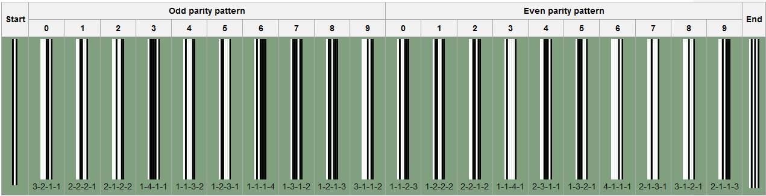

**Figure 3.10 UPC 01 (REF:** [**https://en.wikipedia.org/wiki/Universal_Product_Code**](https://en.wikipedia.org/wiki/Universal_Product_Code)**)**

[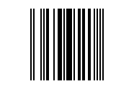](https://en.wikipedia.org/wiki/File:UPC-E-654321.png)The UPC can detect 100 percent of single digit errors and 89 percent of transposition errors. The resulting of barcode example is look like this:

**Figure 3.11 UPC CODE Example (REF:** [**https://en.wikipedia.org/wiki/Universal_Product_Code**](https://en.wikipedia.org/wiki/Universal_Product_Code)**)**

Barcode Scanner / Barcode Reader is an device that decodes the barcode and physically capture information contained in the barcode that consist of the following component which work together to collect, analyze and transmitting data contained in the barcode is :

1. Analyzes data and then sending the content to the scanners output port and a decoder can be internal / external by decoder itself.
2. Scans the barcode image by Lens
3. Illuminate the barcode to make a Light Source
4. Photo conductor will translate optical impulses into electrical ones

Illumination System is the method by which the bars and spaces on the barcode are illuminated. There are variety of illumination systems commonly used in barcode scanner is:

1. Single Point LED

This type of illumination system is exclusive to the barcode wand reader and the barcode slot reader that focused through a single ball-type to touch the barcode while being scanned.

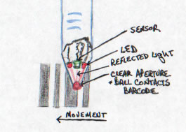

**Figure 3.12 Single Point Led (REF:** [**https://www.carolinabarcode.com/how-barcode-scanners-work-a-69.html**](https://www.carolinabarcode.com/how-barcode-scanners-work-a-69.html)**)**

1. Linear Multiple LED

This type of illumination system is expanding on the single-point illumination system. By placing multiple LED’s in a line that will give an ability to light the entire width of the barcode. Commonly used In CCD scanners and Linear Imagers.

1. Laser

This type of illumination system is the method that uses a single point red laser diode that similar to laser point. Oscillating mirror will expanded the point of light into a line. The distances to scan the barcode are superior from 1mm to 18mm.

1. LED (Light Emitting Diode) Imager

The linear imager and full imager is very similar to CCD device with some important changes like the amount of illumination is increased by using high light LEDs, it will be sense photocells more sensitive mimics both the range and focus of laser scanners. In Full imagers, highly intensity of LED is illuminate a square scanning the target, the light sensors in full imagers very similar to light sensor in monochrome cameras.

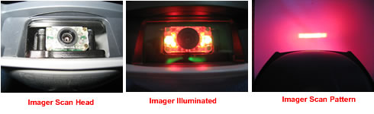

**Figure 3.13 LED’s Imager (REF:** [**https://www.carolinabarcode.com/how-barcode-scanners-work-a-69.html**](https://www.carolinabarcode.com/how-barcode-scanners-work-a-69.html)**)**

By pairing the target square with sensors that search the target square for a valid barcode, the sensors search the scanning square target for a valid barcode. LED full imager are Omni directional that’s you don't have to line up the barcode in any way in order for it to be decoded.

1. Sensor And Converter

This type of illumination system is uses photo detector sense the reflected light that will generates an analog signal with varying voltage. The voltage fluctuatesbased on whether the sensor sees the reflected light from the white spaces because the black bars absorb the red light. Commonly used in CCD (Charge Coupled Device) Readers that use an array of hundreds of tiny light sensors lined up in a row in the head of the reader.

Analog signal from photosensor of barcode scanner

**Figure 3.14 Sensor Of Anaolog Signal (REF:** [**https://www.carolinabarcode.com/how-barcode-scanners-work-a-69.html**](https://www.carolinabarcode.com/how-barcode-scanners-work-a-69.html)**)**

The sensor in this barcode is built in the lens of scanner. Which each sensor can be thought of as a single photo diode that measures the intensity of the light immediately in front of it. Each individual light sensor in the CCD reader is extremely small, because there are hundreds of sensors lined up in a row. Voltage Pattern identical to the pattern in a barcode that’s generated in the reader sequentially that will measuring the voltages across each sensor in the row.

### III.4 The Requirements

Implementing linear barcode in this paper using Android smartphone device and the software “Barcode Reader” to scanning the linear barcode. To implementing linear barcode, not need high specification of Android smartphone but its need minimum requirement:

1. Android Smartphone with camera must be clearly picturing when scanning linear barcode (not blur).
2. The software to scanning linear barcode, in this paper using software that name Barcode Reader and it can be download and get in play store.

The Recommended Requirement to implementing :

1. Android Smartphone with camera 13MP with resolution 4160 x 3120 pixel that have auto-focus, LED Flash, Touch Focus
2. The Barcode Scanner that have a high rank in the play store or that have a web search to search the information product of linear barcode.

### III.5 How It Works

In this paper, the scanner used to scan linear barcode is Camera-Based Reader, Android Smartphone as a device and “Barcode Reader” as the application/software that for implement the scanning of the linear barcode. Scanning linear barcode using Android smartphone device is easier to use than a regular barcode scanner, just need an application to reading linear barcode and can be download and get in play store.

When do scanning the linear barcode using Android Device. First, Point the camera into linear barcode and lets the camera scanning the linear barcode for you (the red lines in barcode scanner application is function to scan the linear barcode). Then after wait for couple of second, the character numerical will be display as the result of scanning that linear barcode. And then, we can search the information of the product of that linear barcode in the internet by tap Web Search in the application result.

### III.6 How To Install The Software Linear Barcode Reader

Before implementing the linear barcode using android smartphone device, we must have a software barcode scanner that installed in your device. To get the software installed to your device:

1. First, open the play store
2. Tap the search button and input “Barcode” or “Barcode Scanner”
3. 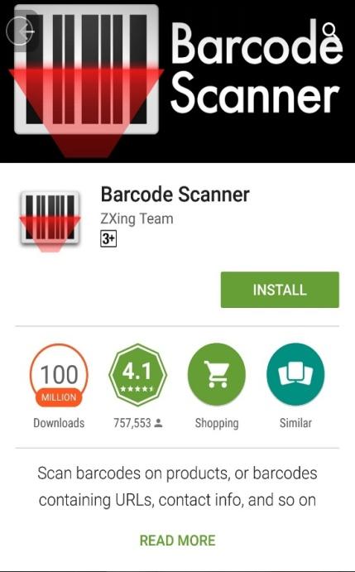Choose the barcode scanner developed by ZXing Team

**Figure 3.15 Software Linear Barcode Reader**

1. Click Install, wait until the install process is done and it will be installed the software into your device.
2. After the install process is finished, The software of Barcode Scanner is ready to use.

### III.7 The Implementation Of Linear Barcode Getting Information

After installing the software of Barcode Reader to your device, now you can use it to scan the linear barcode using your Android Smartphone device and the software of Barcode Reader that already installed in the last:

1. Open the barcode scanner application
2. Point the camera into the linear barcode
3. Scan the linear barcode using your Android Device

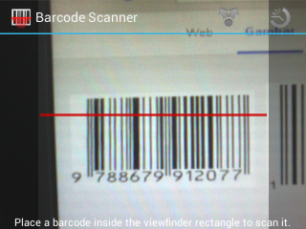

**Figure 3.16 Software Linear Barcode Reader**

1. When the linear barcode already scanned, it will give a result

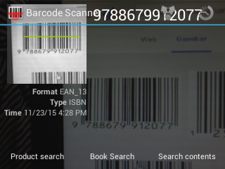

**Figure 3.17 Software Linear Barcode Reader**

1. Then you can check the character of the result scanning the linear barcode in the last by click Web Search

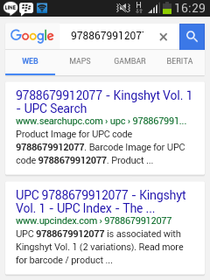

**Figure 3.18 Software Linear Barcode Reader**

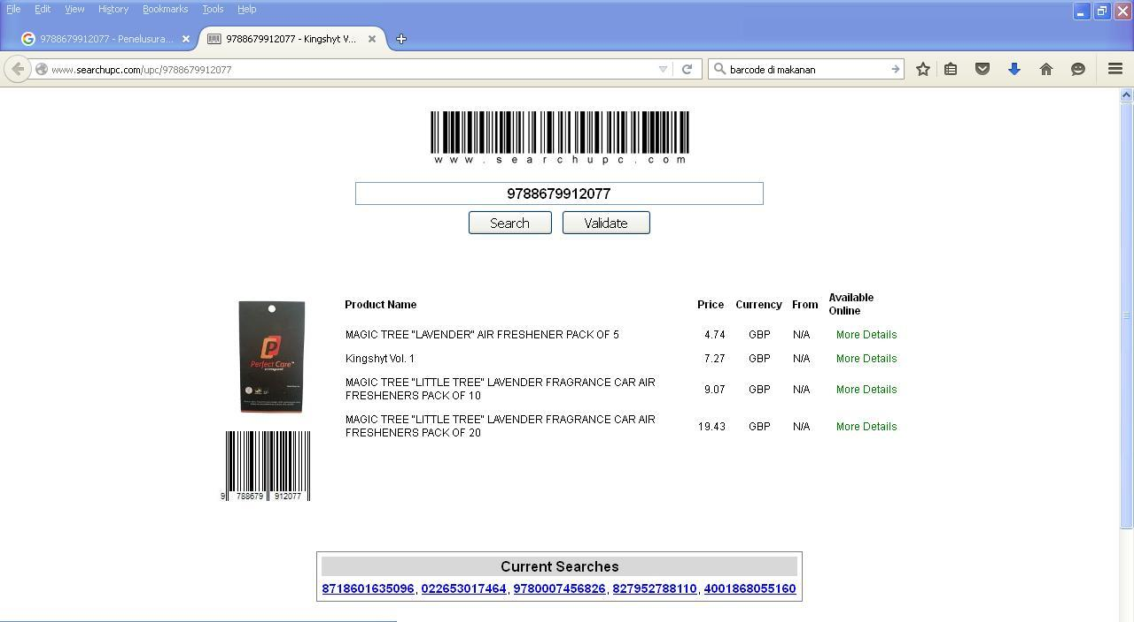

**Figure 3.19 Software Linear Barcode Reader**

1. Then, the information of linear barcode that scanned in the last, it will be display what the product / information have in the linear barcode.

### III.8 Advantages Implementing Linear Barcode Using Android Smartphone

1. We could know the details of the barcode that we scan to look for the code on the Internet
2. Easier to use than a regular barcode scanner, simply by downloading the barcode reader application
3. Can be use wherever you are, because it’s portable device that no need depends on anything else (except the camera).
4. Can be used with everyone’s
5. Very Low-Price

### III.9 Disadvantages Implementing Linear Barcode Using Android Smartphone

1. During dark conditions, the barcode will be hard and can be impossible to scanning, because isn't use an infrared laser to processing the scanning linear barcode.
2. Requires an Internet connection to browse the details of the barcode that has been read
3. Low accurate when the camera isn’t clearly to picture a linear barcode when process scanning (blur when scanning the linear barcode)
4. When the linear barcode isn’t thickness, it will be harder to scanning it and take for couple minutes

When the position of camera when scanning linear barcode isn’t correct, it will be taken for couple minutes to read that’s linear barcode.